**Project Design Phase-II**

**Data Flow Diagram & User Stories**

|  |  |
| --- | --- |
| Date | 26 June 2025 |
| Team ID | LTVIP2025TMID36168 |
| Project Name | HealthAI: Intelligent Healthcare Assistant Using IBM Granite |
| Maximum Marks | 4 Marks |

**Data Flow Diagrams:**

A Data Flow Diagram (DFD) is a traditional visual representation of the information flows within a system. A neat and clear DFD can depict the right amount of the system requirement graphically. It shows how data enters and leaves the system, what changes the information, and where data is stored.

**Example: HealthAI**

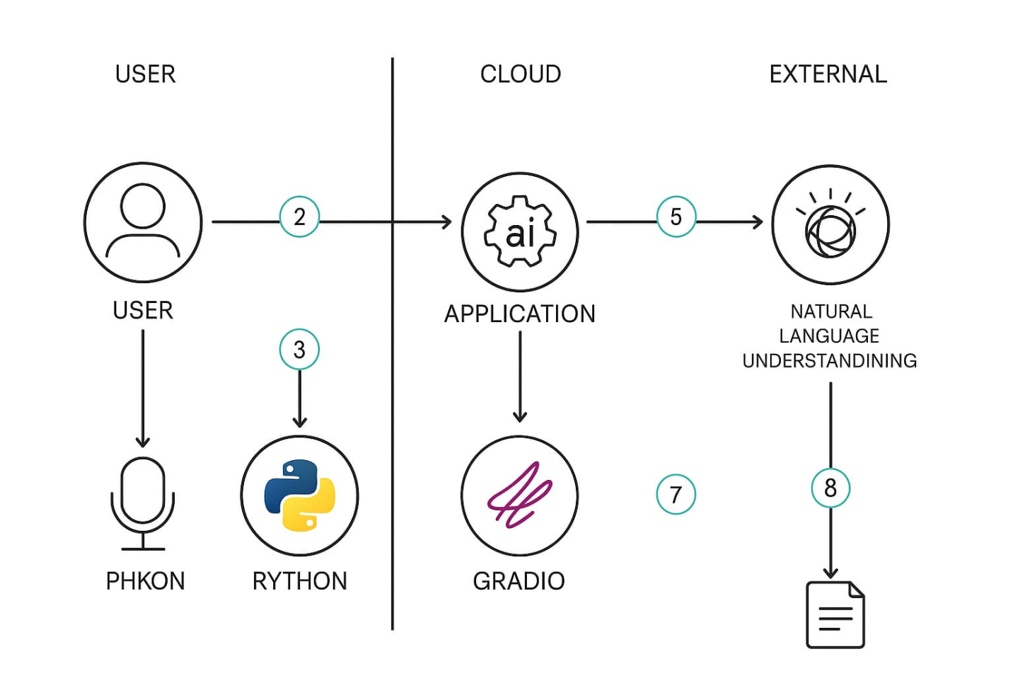

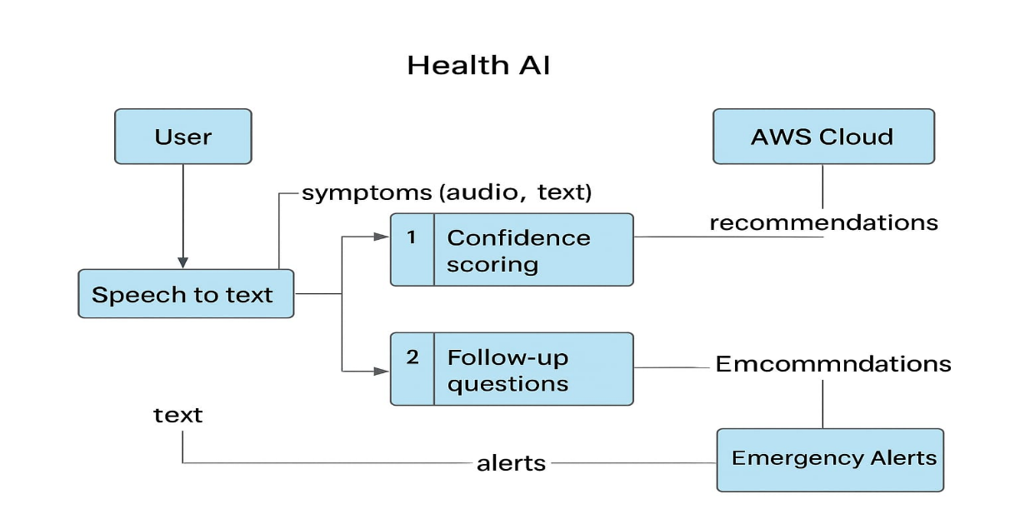

**User Stories**

Use the below template to list all the user stories for the product.

|  |  |  |  |  |  |  |
| --- | --- | --- | --- | --- | --- | --- |
| **User Type** | **Epic** | **User Story #** | **User Story / Task** | **Acceptance Criteria** | **Priority** | **Release Sprint** |
| Customer (Mobile) | Registration | USN‑1 | As a user, I can register by entering email, password, and confirming my password. | Successful registration; user is directed to dashboard. | High | Sprint‑1 |
| Customer (Mobile) | Registration | USN‑2 | As a user, I will receive a confirmation email after registering. | Confirmation email received; clicking it activates the account. | High | Sprint‑1 |
| Customer (Mobile) | Registration | USN‑3 | As a user, I can register using Facebook OAuth. | Facebook login leads to successful dashboard access. | Low | Sprint‑2 |
| Customer (Mobile) | Registration | USN‑4 | As a user, I can register using Google OAuth. | Google login leads to successful dashboard access. | Medium | Sprint‑1 |
| Customer (Mobile) | Login | USN‑5 | As a user, I can log in using my email and password. | Login successful; dashboard is displayed. | High | Sprint‑1 |
| Customer (Web) | Symptom Input | USN‑6 | As a user, I can enter symptoms via text input. | Symptom logged and visible in my history. | High | Sprint‑2 |
| Customer (Web) | Symptom Analysis | USN‑7 | As a user, I receive a top‑3 list of possible conditions based on my symptoms. | Exactly 3 suggestions with actionable next steps appear. | High | Sprint‑2 |
| Customer (Web) | Wellness Advice | USN‑8 | As a user, I get personalized wellness tips (e.g., nutrition, exercise). | At least 3 tips tailored to my age, gender, and lifestyle appear. | Medium | Sprint‑3 |
| Customer (Web) | Home Remedies | USN‑9 | As a user, I receive home remedy suggestions for a specified condition. | 3–5 remedies with brief instructions are provided. | Medium | Sprint‑3 |
| Customer (Mobile) | Reminders | USN‑10 | As a user, I can set reminders for meds, appointments, or routines. | Reminder created and notification received at the set time. | High | Sprint‑3 |
| Customer Care Executive | View User Data | USN‑11 | As a care exec, I can view users’ symptom history and reminders. | All user data is accessible in read-only format. | Medium | Sprint‑4 |
| Administrator | User Management | USN‑12 | As an admin, I can view, deactivate, or promote users. | User list is fully manageable; changes are saved and reflected. | High | Sprint‑4 |